InClass Assignment 7

**Part 1: Network Packet Sniffer (Using PyCharm)**

Steps:

1. Install Dependencies: Ensure you have Python installed on your computer along with the scapy library. Use the following command to install it:

pip install scapy

1. Write the Packet Sniffer Code: Copy the following Python code and save it as packet_sniffer.py:

from scapy.all import sniff

def packet_callback(packet):

print(packet.summary())

# Sniff network packets

print("Starting packet sniffer... Press Ctrl+C to stop.")

sniff(prn=packet_callback, count=10) # Adjust count or remove it for continuous sniffing

1. Run the Code: Open your terminal or Pycharm and execute the code:

python packet_sniffer.py

1. Capture a Screenshot: While running the code, capture a screenshot showing:

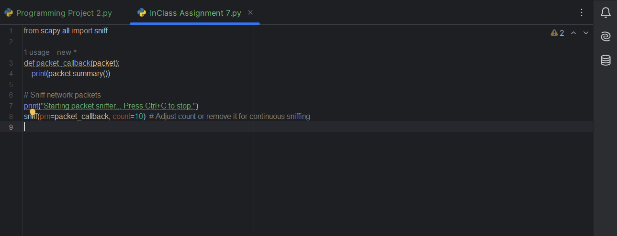

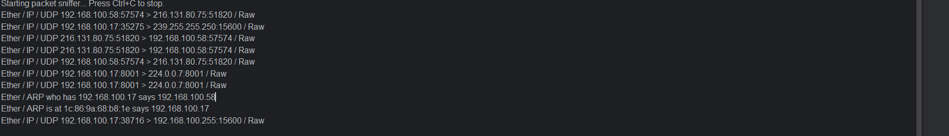

**Part 2: Microsoft Message Analyzer**

Steps:

1. Download and Install:

* Download Microsoft Message Analyzer from a reliable source. (Note: The official download might no longer be available, so check alternative open-source monitoring tools like Wireshark.)
* Install the software and open it.

1. Capture Network Traffic:

* Start a new capture session.

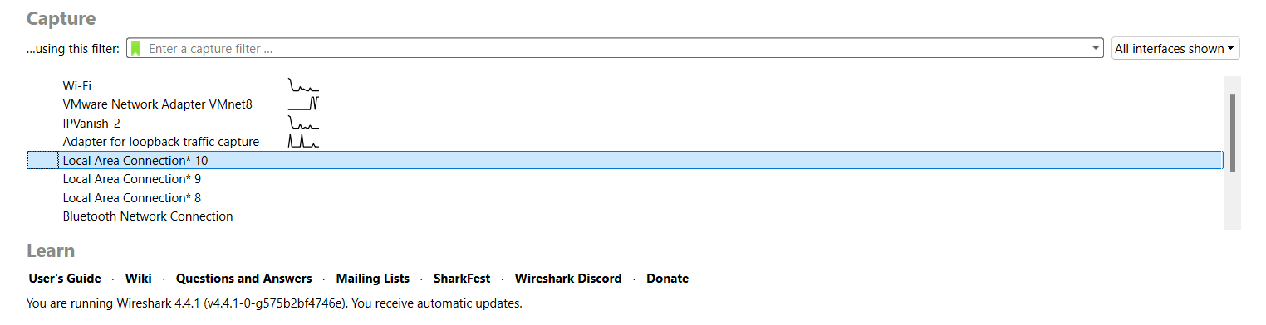

* Select your network interface (e.g., Wi-Fi, Ethernet).

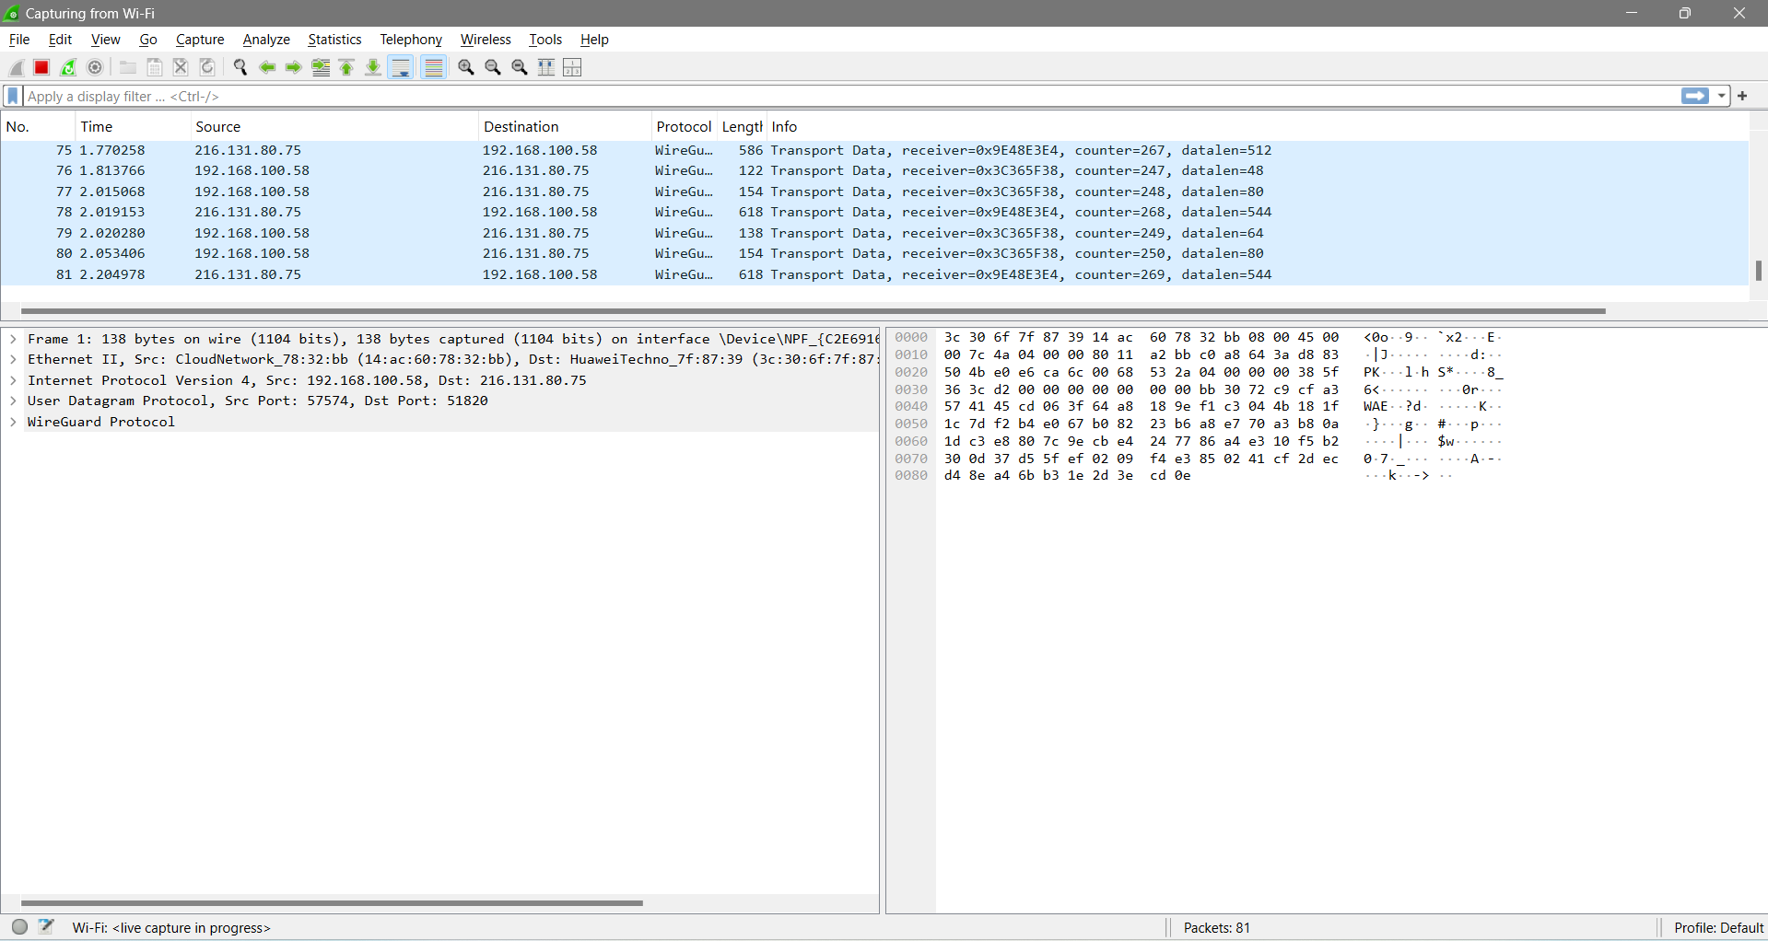

* Begin capturing data and perform simple network activities like loading a webpage.

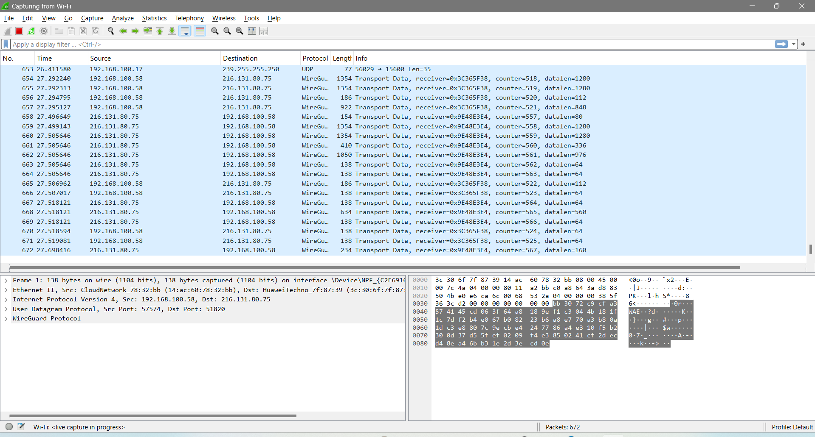

1. Analyze Captured Packets:

* View and filter specific protocols like HTTP, TCP, or DNS.
* Use the tool's features to decode messages and display traffic events.

1. Document and Explain: Create a document explaining:

* How you captured network packets.
* Key findings from your analysis.
* The purpose of different protocols observed in the traffic.

